STAR schema

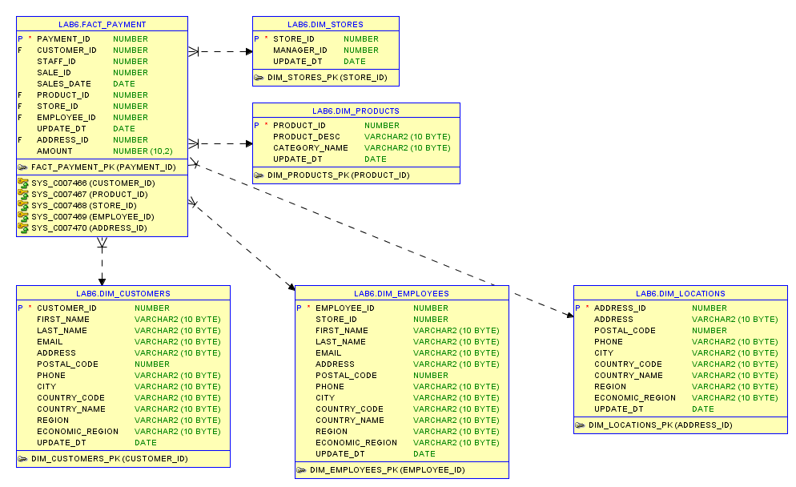

**Steps**

**Step 1:** Select the Business Process

Business Process is connected to sales.

**Step 2:** Declare the Grain

A grain is a single payment

**Step 3:** Identify the Dimensions

Table DIM_PRODUCTS consists of products and categories.

Table DIM_CUSTOMERS contains available information about customers..

Table DIM_STORES contains information about existing stores.

Table DIM_EMPLOYEES contains available information about employees.

Table DIM_LOCATIONS contains information about locations, where payment took place.

**Step 4:** Identify the Facts

Payment_id, Customer_id, Staff_id, Sale_id, Sales_date, Product_id, Store_id, Employee_id, Update_dt, Address_id, Amount.

SNOWFLAKE shema:

